Engr228 Prelab #1 Spring, 2020

Laboratory Introduction, DC Measurements

Name ___________________________ Grade _______/10

Notes

- You are welcome to collaborate with your classmates, or complete this prelab assignment individually.
- Round all of your results to four significant digits but carry more digits in intermediate calculations.

Part 1 – Setup

- Unpack your collection of parts you received from the instructor.

- Complete the Getting Started Guide appropriate to your operating system.

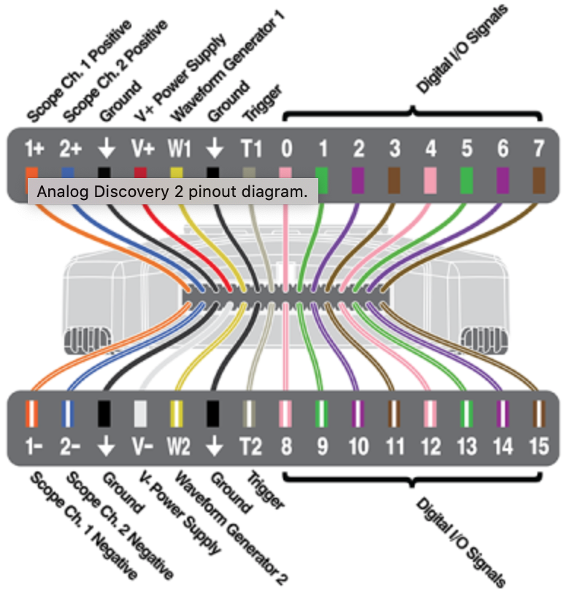
- If you wish, place Flywire labels (from the sticky-backed sheet) onto the 10 left-hand signals shown below. We probably won’t use the other signals this quarter.

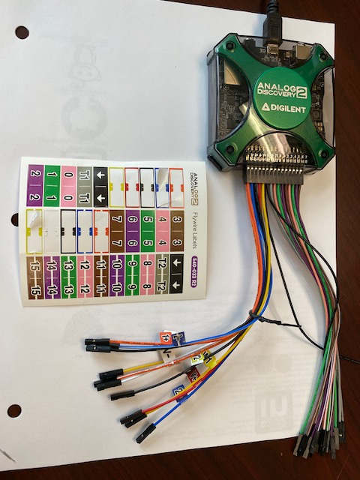

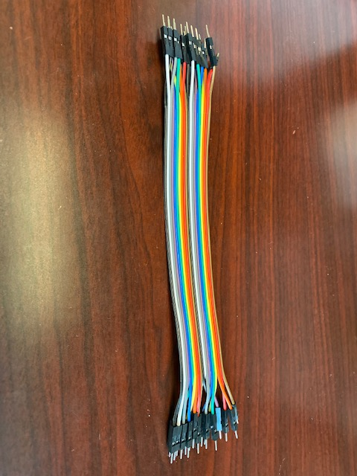
- The cable bundle in your kit shown at the right are individual wires that can be separated. You can use them to connect external signals to your breadboard if necessary, and connect components together on your breadboard.

- Complete the following tutorials to familiarize yourself with the basic features of your lab kit and the Analog Discovery 2 instruments:

- Breadboards and Multimeter Functions - Voltage, Current, and Resistance Measurement
- Calibrate your AD 2 (Optional for now – guide has a few bugs)
- Using the AD 2 Power Supply

Part II – Ohm’s Law

- The following data was measured in a laboratory setting:

V_{out} (V) | 0.3 | 0.6 | 0.9 | 1.2 | 1.5 | 1.8 | 2.1 | 2.4 | 2.7 | 3.0 | 3.3 | 3.6
I_{R2}(mA) | 10.1 | 20.9 | 29.2 | 41.6 | 49.1 | 60.7 | 70.0 | 81.2 | 89.4 | 101 | 108 | 120

- Enter the data from the above table into Excel and make a plot with V_{out} on the y-axis and I_{R2} on the x-axis. Overlay the raw data plot with a linear least-squares fit line. Create meaningful titles for your axes. Print out a copy of this graph and turn it in with your pre-lab report. Please pay special attention to the handout on the course web page entitled School of Engineering Graphing Standards. The standards stated in this document will be used as the basis for the grading of your graphs.

- Record the slope of the line here: _______________ (Ω)

Part III – Ohm’s and Kirchhoff’s Laws

v_{s} = 5 volts
R₁ = 10kΩ
R₂ = 20kΩ

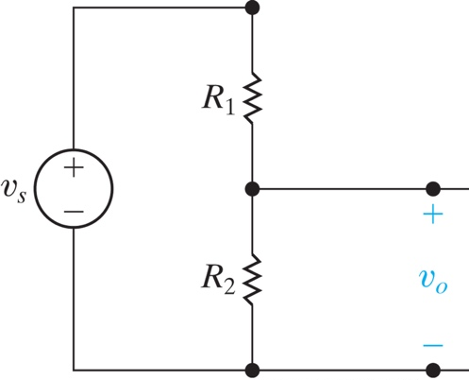
- Using the values above, calculate v_{o} for the circuit shown at the right:

- Using the same values, calculate the voltage across R₁

To Turn In

Print out this document, do your calculations right on it, add your graph to it, scan or take pictures, and place in the prelab1 drop box in D2L.

References

Analog Discovery 2

- Product Description
- Specifications
- Reference Manual
- Overview page with Tutorial Links

Waveforms Software

- Download
- Reference Manual

Online Instruction

- Overview
- Circuits Course - Real Analog

