Engr228 Lab #8 Spring, 2020

Power Factor Correction

Name _____________________________

Introduction
Voltage and current waveforms as applied to complex loads tell us a great deal about the power environment surrounding these loads. This lab will guide you through the analysis of a simple circuit with a sinusoidal excitation. You will make measurements to calculate various power quantities, and learn how to improve the power factor.

Objectives
- Apply classroom principles and theory to physical devices;
- Understand complex power issues using a real circuit;
- Understand the benefits of power factor correction.

Equipment
- Waveforms software;
- Digilent Analog Discovery 2 Module;
- Breadboard;
- Assorted components and wires.

References
- Digilent Real Audio YouTube video;
- Zybooks text book;
- Course web site;
- Resistor color-code chart.

Procedure
Your lab this week will be shorter, providing you more time to focus on getting your final assignments done and studying for the final quiz. You will be duplicating the work done in the video whose link is below. The video and this lab exercise will help you appreciate the issues involved in power generation, transmission, and usage.

https://www.youtube.com/watch?v=k0mdwQvn2iw&list=PL170A01159D42313D&index=25

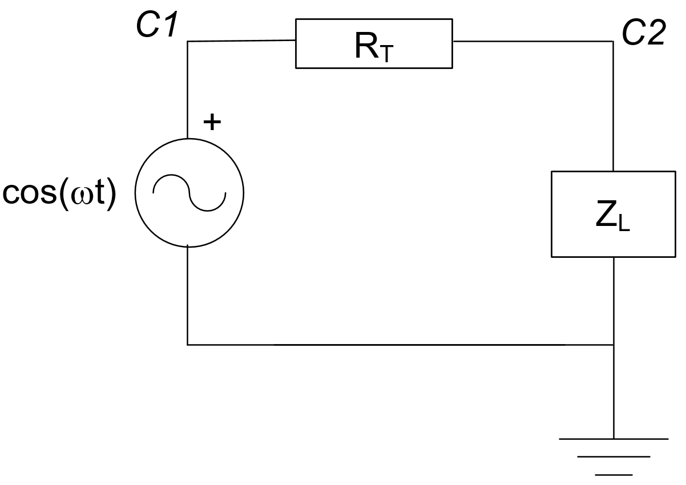
- Construct the same circuit as you see in the video (shown at the right) with the following component values:

R_{T} = 51 Ω
R_{L} = 100 Ω
L_{L} = 22 uH
Frequency = 1 MHz
V_{source} = 1V_{Peak}

Note that Z_{L} = R_{L} + jwL_{L}

- Setup your oscilloscope so that channel 1 measures the voltage across the source, and channel 2 measures the voltage across the load. Create a math channel that shows the current through the circuit: (C1 – C2)/R_{T}

- Calculate the current through and the average power dissipated in R_{T}

I = ___________________________ P = ____________________________

- Calculate the power factor of the load.

pf __________________________
- Calculate and measure the phase difference between the voltage across and the current through the load.

(θ_{V}-θ_{I})_{calc} _____________________ (θ_{V}-θ_{I})_{meas} ______________________

- Place your 0.1uF capacitor across the load. Make sure it is in parallel with both R_{L} and the inductor.

- Calculate the power factor of the load with the capacitor added in parallel.

pf __________________________

- Calculate the current through and the average power dissipated in R_{T} with the power factor correction capacitor added across the load.

I = ___________________________ P = ____________________________

- Oops – things didn’t go quite as planned, did they? Explain below what you found out, and how you might correct this situation (i.e. how to bring the PF of the load to unity thereby reducing the amount of current required from the source).

- Submit your finished lab to the lab8 drop box by 4pm on Friday, June 5.

