Engr228 Prelab/Lab #1 Spring, 2020

Laboratory Introduction, DC Measurements

Name ___________________________

Notes

- You are welcome to collaborate with your classmates, or complete this lab assignment individually.
- Round all of your results to four significant digits but carry more digits in intermediate calculations.

Part 1 – Setup

- Unpack your collection of parts you received from the instructor.

- Complete the Getting Started Guide appropriate to your operating system.

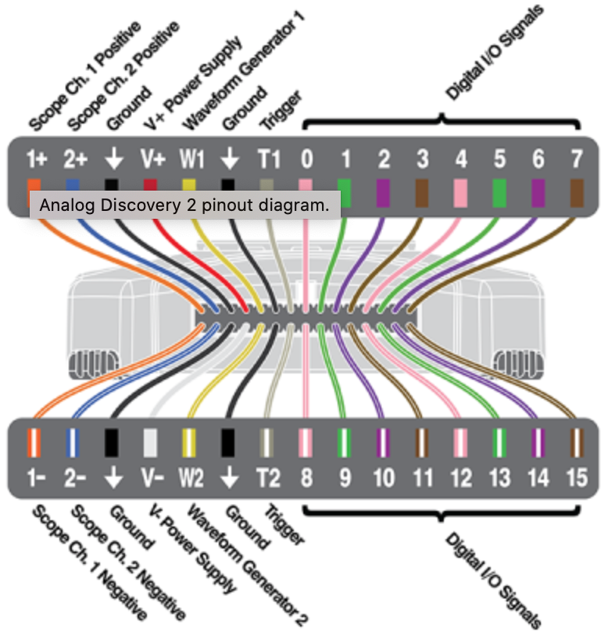
- If you wish, place Flywire labels (from the sticky-backed sheet) onto the 10 left-hand signals shown below. We probably won’t use the other signals this quarter.

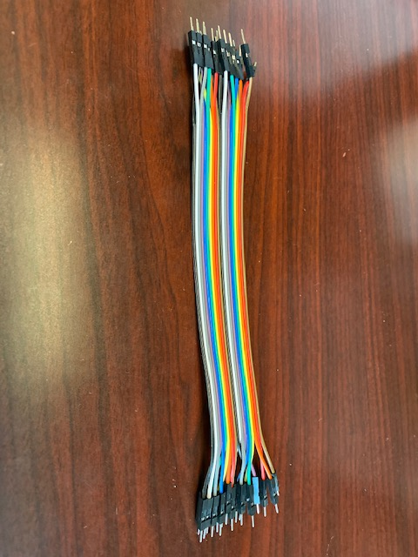
- The cable bundle in your kit shown at the right are individual wires that can be separated. You can use them to connect external signals to your breadboard if necessary, and connect components together on your breadboard.

- Complete the following tutorials to familiarize yourself with the basic features of your lab kit and the Analog Discovery 2 (AD 2) instruments:

- Breadboards and Multimeter Functions - Voltage, Current, and Resistance Measurement
- Calibrate your AD 2
  - Include units when entering values (V or v for volts).
- Using the AD 2 Power Supply

Part II – Ohm’s Law

- The following data was measured in a laboratory setting:

V_{out} (V) | 0.3 | 0.6 | 0.9 | 1.2 | 1.5 | 1.8 | 2.1 | 2.4 | 2.7 | 3.0 | 3.3 | 3.6
I_{R2}(mA) | 10.1 | 20.9 | 29.2 | 41.6 | 49.1 | 60.7 | 70.0 | 81.2 | 89.4 | 101 | 108 | 120

- Enter the data from the above table into Excel and make a plot with V_{out} on the y-axis and I_{R2} on the x-axis. Overlay the raw data plot with a linear least-squares fit line. Create meaningful titles for your axes. Print out a copy of this graph and turn it in with your pre-lab report. Please pay special attention to the handout on the course web page entitled School of Engineering Graphing Standards. The standards stated in this document will be used as the basis for the grading of your graphs.

- Record the slope of the line here: _______________ (Ω)

Part III – Component Measurement

- From your resistors, select the following values: R₁ = 330Ω, R₂ = 470Ω, and R₃ = 1000Ω.

- Using your meter, measure and record the value of each resistor and place in the table below.

- Using the following formula, calculate and record the percentage error. Note that your percentage errors should all be less than 5%.

$$Percentage Error= |(Nominal value-Measured value)|/(Nominal value)*100\%$$

Resistor ID | Nominal Value (Ω) | Measured Value (Ω) | Percentage Error (%)
R₁ | 330Ω
R₂ | 470Ω
R₃ | 1000Ω

- Refer to the Solderless Breadboards hand-out provided on the course web page. Using your solderless breadboards, fill in the following table by placing the resistors in series or parallel configurations as indicated. Refer to your Zybooks, section 2.4, on how to calculate the equivalent value of resistors in series and parallel configurations.

Resistor Configuration | Calculated Value (Ω)  (use measured values from step 3) | Measured Value (Ω) | Percentage Error (%)
R₁⏐⏐R₂
R₁⏐⏐R₃
R₂⏐⏐R₃
R₁⏐⏐R₂⏐⏐R₃
All 3 in series

Part IV – Ohm’s and Kirchhoff’s Laws

v_{s} = 5 volts
R₁ = 330Ω
R₂ = 470Ω

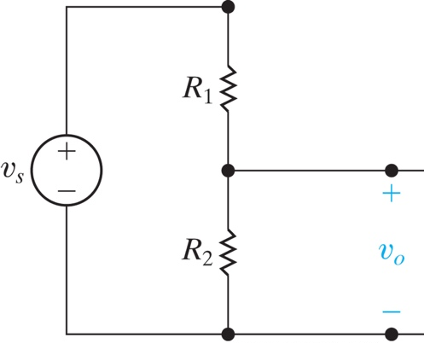
- Using the resistor values above, calculate v_{o} for the circuit shown at the right. Use your measured values from Part III of this lab.

- Wire up the circuit using your AD 2 module to set v_{s} = 5 volts. Measure v_{o} with your meter and record here:

v_{o} ______________ V

- Using the same resistor values, calculate the voltage across R₁

- Measure v_{R1} with your meter and record here:

v _{R1} ______________ V

To Turn In

Print out this document, do your data entry right on it, add your graph to it, scan or take pictures, and place in the lab1 drop box in D2L by 2pm on Friday, April 10.

